Edited by: Mahnaz Sharafkhani, Hector Diego Estrada-Lugo, Maria Chiara Leva, Leonard O’Sullican, Marie Elizabeth Ward, Joan Cahill, Sara Dockrell.
Irish Human Factors and Ergonomics Society Annual Conference 2023
Copyright © The Authors, The Editors, The Irish Human Factors & Ergonomics Society
Irish Ergonomics Review 2023
ISSN 1649-2102
12 June 2023, Central Quad, TU Dublin

Table of contents
A Taxonomy of Intraoperative Grasp Types Performed By Clinical Users During TAVI And TMVR Procedures 2
Data, Socio-Technical knowledge and the potential for system transformation 14
Integrating Human Factors in Ireland’s National Train Control Centre 22
Smart Self-care for Dementia – Do-designing Assistive Technology with and for People with Dementia 24
Midwives’ Views of an Evidence-Based Intervention to Reduce Caesarean Section Rates in Ireland 26
Occupational Safety and Health Guidance for Remote Working 27
Analysis of Clinical Negligence Claims and Complaints Against GPS to The Irish Medical Council: Exploring Local Rationality and Performance Influencing Factors 29
Patient-Centred Human Factors: A Narrative Review in the ICU Context. 31
Evaluating Accessibility Issues in Healthcare Data Representation with Older Adults 33
Managing Mechanical Safety In Industrial Human-Robot Interaction 35
Foreign Object Management in Irish Hospitals 36
Neuroergononomics and Physiological Computing: New Methods To Enhance Human-System Interaction 41

Full papers

Paper ID: 1

A Taxonomy of Intraoperative Grasp Types Performed By Clinical Users During TAVI And TMVR Procedures
Gráinne N Tyrrell, Leonard O’Sullivan, Donna Curley, Eoin J White
School of Design, University of Limerick, Ireland

Abstract
Aim: This study aims to identify and quantify grasp types occurring intraoperatively during TAVI and TMVR procedures. Catheter-based procedures introduce a high level of complex hand actions and sufficient data for optimal device design is not prevalent in the literature.
Methods: Instance rate and duration of grasp-types were extracted from footage of TAVI and TMVR cases and were categorised and compared.
Results: Pinch-grip had the highest instance rate (n=942). Other prevalent grasp- types were lateral tripod (n=664) and lateral pinch (n=441). Combined grasps were also logged, which may indicate overcomplex or sub-optimal interface design.
Conclusions: There are currently no recommended guidelines for optimal forces related to certain grasp-types occurring intraoperatively for TAVI and TMVR. This study’s findings can be used to better understand how users interact with devices.

Introduction
Minimally invasive cardiovascular procedures require clinical experts to perform a wide variety of hand grasps and manipulations with varying levels of force and precision. Transcatheter Aortic Valve Implantation (TAVI) and Transcatheter Mitral Valve Replacement (TMVR) are two such interventions which introduce a high level of complexity in terms of user performance. TAVI is the standard minimally invasive option for treating symptomatic acute aortic stenosis (Veulemans et al. 2023). TMVR is an emerging intervention to treat mitral valve regurgitation due to mitral valve disease (Zahr et al. 2022). Catheter-based procedures infer use scenarios in which users must interact with small diameter devices. The way in which these interfaces are interacted with is inherently different to the sample data which is available in Human Factors (HF) standards. AAMI HE75 (AAMI 2018) and I.S. EN 62366-1 (IEC 2015) encapsulate standards and guidelines which pertain to max recommended forces for various grasps. However these are limited and do not always provide industry with sufficient data for optimal device design (Dianat et al. 2018).
The paper ‘A review of the methodology and applications of anthropometry in ergonomics and product design’ (Dianat et al. 2018) identified the need for context-specific anthropometric data to inform design. The standard HE75 cites anthropometry books and numerous military sources, however, these are often outdated, unsuitable, and not widely available, making it difficult for designers or engineers to apply these data during the product development process. Table 1 displays the results of a literature search for user grasps and their corresponding force recommendations.
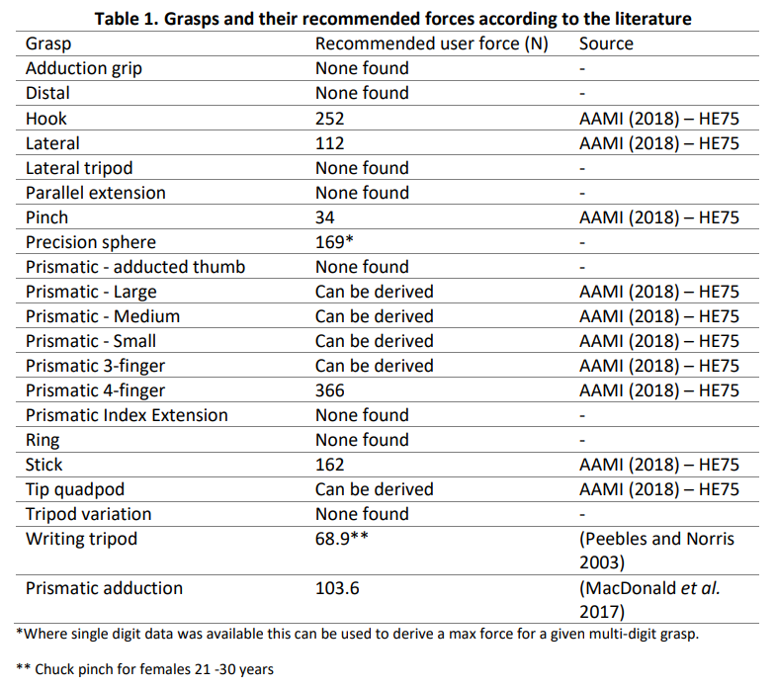
Digital methods of anthropometry acquisition are becoming ever prevalent. 3D scanning has been used to expedite the development of datasets for multiple measurements (Pleuss et al. 2019). While this may be appropriate for body measurements, accurate measurements of user forces for small diameter objects presents a more complex task. Further to that, implementing force data acquisition within use scenarios can yield more accurate readings but can be difficult to achieve.
This study aims to identify and quantify grasp types occurring intraoperatively during TAVI and TMVR procedures. These data are impertinent to the design of more suitable deployment devices for all clinical stakeholders. An improved understanding of the grasps and manipulations which occur during catheter-based cardiovascular procedures may allow for more use specific force testing to be conducted during the product development process.

Methods
Data Acquisition
Video footage from both TAVI and TMVR live case studies were used to extract and record frequency and duration of grasps, and corresponding devices, used intraoperatively. Publicly available live case studies were used. For TAVI, the search terms “TMVR” “mitral valve replacement” and “live case” were used to gather suitable data sources. For TAVI key search terms were: “TAVI”, “TAVR”, “aortic valve replacement” and “live case”. The search terms for each procedure were input into a video library; in this case Youtube was used. Due to time and resource restraints, a total of 4 of the eligible videos were analysed. Videos were assigned an identifier for clarity and consistency (see Table 2 below). Procedural length was identified by referring to the steps outlined in openly available Instruction for Use documentation for both procedures. Because the nature of these live case studies, videos often contained supplementary discussions before, during, and after the procedure. Thus, video lengths differed from actual procedural lengths. The elected case studies are detailed in the table below.
Table 2. Character of the videos included in this study
Procedure | ID | Video Length | Procedure Length | Source
TMVR | TMVR S1 | 00:57:28 | 0:33:37 | (CCC Live Cases 2019)
TMVR | TMVR S2 | 00:32:49 | 0:23:58 | (New York Transcatheter Valves 2022)
TAVI | TAVI S1 | 01:00:08 | 0:19:44 | (PCR 2018)
TAVI | TAVI S2 | 00:50:20 | 0:17:08 | (CCC Live Cases 2021)

Logging
For each video, both primary and secondary operators were assessed unimanually. Thus, videos were reviewed four times each to accurately capture grasps, movements, and manipulations. Data logging took approximately 8 hours per video. Duration of interaction for both grasps and devices were logged in Excel spreadsheets. (Arapi et al. 2021). Frequency of grasps, and their corresponding user interface, were recorded under ‘instance’. An example of the methodology is displayed in Figure 1.
The taxonomy outlined by Arapi et al. (2021) categorises some grasps under the label ‘other’. These grasps could fall under either the ‘precision’ or ‘power’ grasp categories. This taxonomy is outlined in Table 3. A ‘combined’ category was also used so that grasps which showed characteristics of more than one grasp in the taxonomy could be recorded. This approach is outlined in Figure 2. Novel grasps which did not fall under any of the grasps outlined in the methodology were also highlighted. Data was subjected to descriptive statistical methods to compare duration and frequency measures. For both TAVI and TMVR, individual operators and their individual hand actions were analysed and compared against multiple other variables.
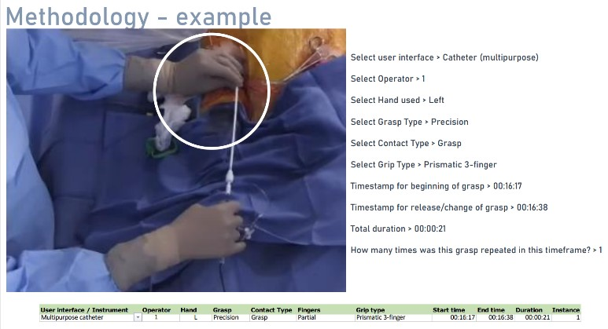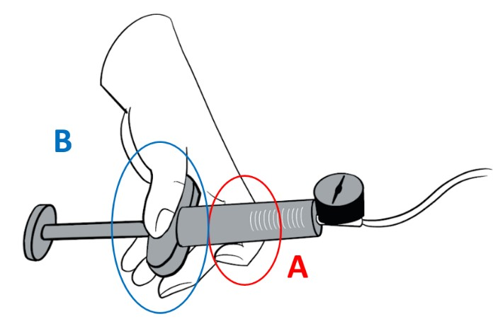
Figure 1. Example of how grasps were logged
Figure 2. Combined grasp interpretation. Ahook grasp. B: prismatic palm grasp.

Table 3. Grasp labelling (Arapi et al. 2021)
Power | Precision | Other
Sphere  Ring  Hook  Extension  Light tool  Parallel Extension  Power disc  Palmar disc  Prismatic Index extension  Prismatic Large  Prismatic medium  Prismatic small  Ventral  Prismatic adducted thumb  Stick | Lateral tripod  Tripod variation  Writing tripod  Inferior pincer  Tip Tripod  Tip Quadpod  Precision sphere  Precision disc  Prismatic 4 - finger  Prismatic 3-finger | Distal  Adduction grip  Open hand  Environmental Exploitation

Results
Overall, the most common grasps were pinch grip (n=942), followed by lateral tripod (n=664) and lateral pinch (n=441). HE75 recommended forces for pinch and lateral grip are 34N and 112N respectively. There was no existing force data pertaining to the lateral tripod grip found.
Other prevalent grasps such as lateral tripod, ring and variations of prismatic grasps did not have any max force guidelines in either HE75 OR ISO 62366, nor in any other openly available anthropometric data source. This was the case for several other grasps. Figure 3 compares the mean frequency of grasps logged for both TAVI and TMVR. Unless otherwise stated, the mean of the respective studies was used for the following results.
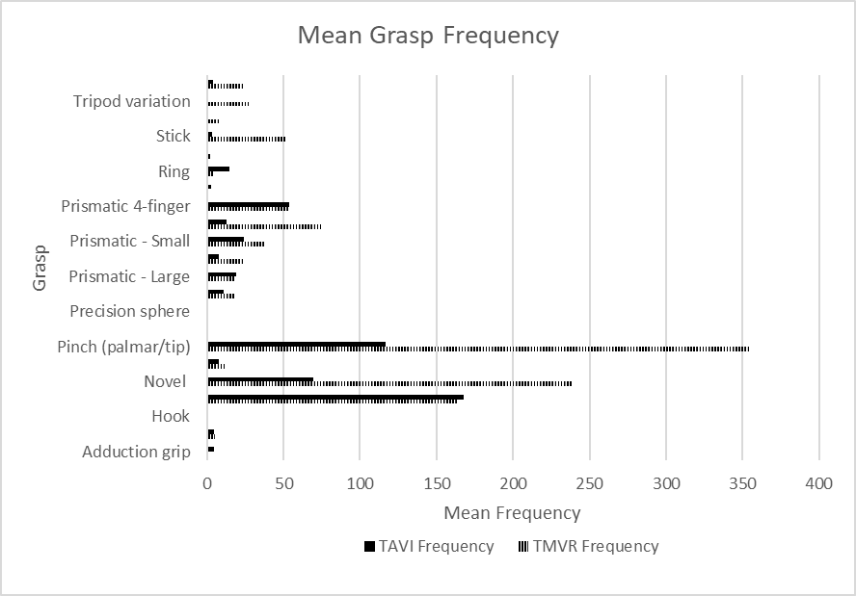
Figure 3. Mean frequency of TAVI and TMVR grasp types performed by both operators
TMVR
The majority of grasps performed during TMVR were precision grasps (71.35%). Power grasps made up 22.51%, 6.04% were combined precision and power grasps (see Discussion section for further detail) and 0.09% were logged as ‘other’ which included open-hand manipulations and environmental exploitations.
Pinch grip was the most common grasp for TMVR, and it was performed 355 times between both primary and secondary operators throughout the procedure. The pinch grip was engaged for a total of 35 minutes and 20 seconds. The primary operator performed the pinch grip 264 times, compared to the secondary operator who performed it 91 times.
Novel grips occurred an average of 239 times (22m05s), with Operator 1 performing the majority of these (n=195; 06m33s). These grasps are detailed in the Discussion section below. The lateral tripod grasp was the next most frequent (n=164; 19m03s) and the first operator’s right hand performed 60% of these grasps. As depicted in Figure 4, catheters had the highest interaction rate by users (20m50s). Guidewires followed closely with an average duration of interaction of 19m35s.
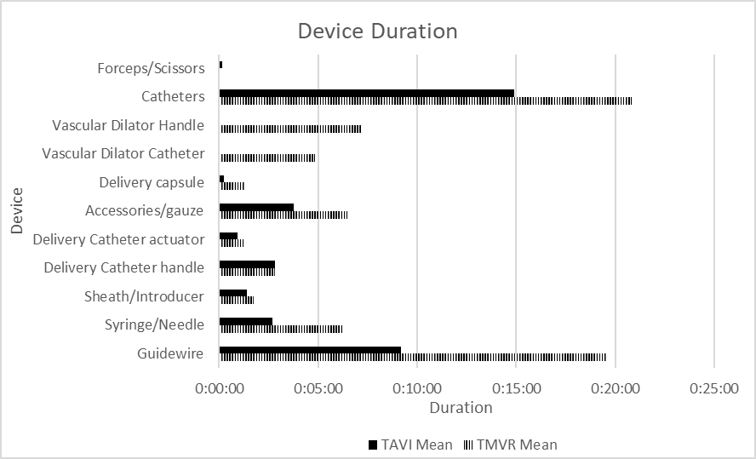
Figure 4. Case 1 and 2 TMVR device interaction durations
TAVI
1059 instances were assessed for TAVI procedures (483 for case 1 and 570 for case 2). As with TMVR, precision grasps were the most prevalent and equated to 84% of grasp types. 14% of grasps were power grasps, 1.5% were combined grasps and 0.7% were labelled ‘other’.
168 instances of lateral tripod grip were recorded making this the most common grasp for TAVI procedures (07m39s). This was primarily performed by the first operator, who executed the lateral tripod grip 138 times (06m25s) throughout the procedure. This is 4.5-fold that of the second operator. Pinch grasp was close behind (n=117, 07m05s). Novel grasps occurred an average of 70 times, (05m33s). Again, catheters were the most common user interface interacted with by users (14m54s). Users spent 09m11s interacting with guidewires.
Novel grasps
Grasps which did not fall within the characteristics outlined in the methodological approach were logged as novel grasps. Alternatively grasps which were a combination of two or more existing grasps were described as such. Figure 5 shows one such grasp in which the user uses one hand to feed a guidewire into a catheter. Pinch with cylindrical grip was the most common novel grasp logged (n=143, 31m47s). The following novel grasps were identified by this study.
Table 4. Novel grasps
Novel Grip | Time | Instances
Prismatic adduction | 0:01:10 | 14
Pinch grip with cylindrical | 0:31:47 | 143
Pinch with Adduction Grip | 0:00:23 | 6
Hook with Tip Pinch | 0:00:04 | 1
Hook with environmental exploitation | 0:00:08 | 2
Sphere with D2 &D3 extension | 0:00:06 | 5
Hook with D1 & D2 Abduction | 0:00:04 | 1
Prismatic with D2 Hook | 0:02:36 | 1
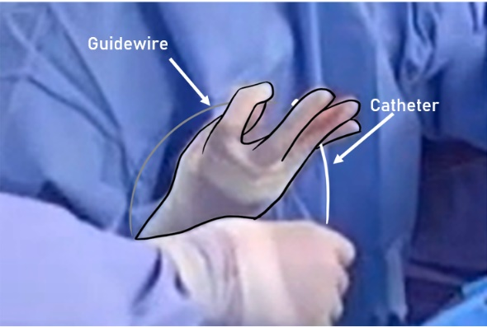
Discussion
The findings of this study indicate that average procedural times for TMVR was 0:28:47 and TAVI was 0:18:26, however this is not considered a significant finding of the study. The nature of live cases studies means they contain educational discussions and demonstrations throughout the recording, and videos do not reliably record the full duration of the procedure - both characteristics impact on the authenticity of the recorded procedural duration. According to Durand et al. (2021), procedural duration and the length of stay for TAVI patients varies considerably due to comorbidities, complications and case-to-case variables.
Of the 28 logged grasps, a literature search yielded relevant user force data for only 8 of these. 5 of these were sourced from AAMI HE75 Human Factors standard, of which reference data is derived form a male-only cohort.
Precision grasps were repeated many times within a small window frame, for example when feeding a wire through a catheter, or advancing a sheath through an access site. According to HE75, once an action becomes repeated the recommended forces are 20% of the max voluntary contraction for a given grasp (AAMI 2018).
This study identified several ‘workarounds’ employed by users, prompted by suboptimal design and awkward use conditions. The novel grasp identified by this paper are indicative of over-complexity of device-user interactions. This is particularly evident where users need to advance or retract the system and keep a guidewire stationary.
Additionally, there were times where the user had to employ a level of force which would ideally have been conducted with a power grasp. Due to the small diameter of guidewires (often 0.94mm) and catheters (14-18mm), users were forced to use precision grasps. This led to workarounds such as bimanual reinforcement, employing suboptimal postures to leverage bodyweight, and using environmental exploitation to achieve the desired actuation.
Novel grasps
This study unearthed several novel grasps which did not fall within the characteristics outlined in the methodology. Many of these grasps displayed characteristics of two or more grasp types. These may indicate overcomplexity of actions required during device use or may indicate sub- optimal interface design. The most common novel grasp was the pinch with cylindrical power grip. This has been identified previously by (Park et al. 2022), who detailed the prevalence of this grasp type within the field of biomedical design.
When performing an injection motion with a syringe or inflation device, users often employed a variety of different grasps. Balloon inflation requires high forces and inflation devices are significantly larger than the typical syringe used during these procedures (often 100ml). It was observed that users reinforced this manipulation by using two hands to complete the action. MacDonald et al. (2017) conducted a study which analysed grip types and their corresponding forces for syringe use. This study acknowledged the variety in possible grasps used for injecting. It also highlighted that at there is most risk for user strain when at the widest part of the action (i.e. at the beginning of injecting).
One of the most common grasps recorded was the lateral pinch grasp. This grasp was not represented in the methodology which this study leveraged. However, this grasp has been referenced in a variety of literature (Peebles and Norris 2003) (Mehrkish and Janabi-Sharifi 2021) (Staretu 2019), and therefore was not deemed a ‘novel’ grasp. The lateral pinch was often employed by users when grasping small diameter interfaces such as guidewires and catheters. 54% of lateral pinches were used to interact with guidewire, and 22% to interact with catheters.
Future work and limitations
The sample size of this study was small (n=8 users). This was due to time and resource restrictions. Similar studies can be expedited by using existing video analysis programmes for the application of grasp identification. Interrater methodologies should be employed for similar studies to further validate data. There is an evident need for future work which gathers force data from clinical users whilst performing catheter-based procedures. Horsfall et al. (2022) developed a sensorised surgical glove which accurately measured user forces of neurosurgeons whilst maintaining a realistic use condition. The development of similar technologies for catheter-based procedures could greatly enhance the applicability of force data in this field. Existing guidelines need to be updated to reflect the current anthropometric databases available and efforts to make data more easily interoperable are imperative.
Conclusions
- The most common grasps for TAVI and TMVR were pinch grip and lateral tripod.
- A variation of grasps are prevalent during these procedures, however there are no guidelines pertaining to their recommended forces or related design guidelines.
- A number of novel grasps unique to catheter-based procedures were identified.
- Digital methods have potential to effectively fulfil the gap in available grasp force data which informs the design of cardiovascular devices.
Acknowledgements
This research was funded by the Irish Research Council and Medtronic SH&A Human Factors Team under the IRC Enterprise Partnership scheme.
References
AAMI (2018) 2009(R2018)AAMI HE75 Human factors engineering—Design of medical devices, United States: AAMI - Assoc. for adv. of Medical Instrument.
Arapi, V., Della Santina, C., Averta, G., Bicchi, A. and Bianchi, M. (2021) 'Understanding human manipulation with the environment: a novel taxonomy for video labelling', IEEE ROBOTICS AND AUTOMATION LETTERS, 6(4), 6537-6544.
CCC Live Cases (2019) Mitral ViV TMVR using SAPIEN-3 Valve - May 2019, available: https://www.youtube.com/watch?v=jRXn1van1Ug [accessed 15/01/2023].
CCC Live Cases (2021) TAVR with 23mm SAPIEN-3 Ultra Valve with LM Protection, available: https://www.youtube.com/watch?v=saMUq_0IO0w [accessed 15/01/2023].
Dianat, I., Molenbroek, J. and Castellucci, H.I. (2018) 'A review of the methodology and applications of anthropometry in ergonomics and product design', Ergonomics, 61(12), 1696-1720.
Durand, E., Avinée, G., Gillibert, A., Tron, C., Bettinger, N., Bouhzam, N., Gilard, M., Verhoye, J.P., Koning, R. and Lefevre, T. (2021) 'Analysis of length of stay after transfemoral transcatheter aortic valve replacement: results from the FRANCE TAVI registry', Clinical Research in Cardiology, 110, 40-49.
Horsfall, H.L., Fernandez, C.S., Bagchi, B., Datta, P., Gupta, P., Koh, C.H., Khan, D., Muirhead, W., Desjardins, A. and Tiwari, M.K. (2022) 'A Sensorised Surgical Glove to Analyze Forces During Neurosurgery', Neurosurgery, 10.1227.
IEC, I. (2015) '62366-1: 2015 Medical Devices—Part 1: Application of usability engineering to medical devices', International Electrotechnical Commission (IEC), Geneva.
MacDonald, V., Wilson, K., Sonne, M.W.L. and Keir, P.J. (2017) 'Grip Type Alters Maximal Pinch Forces in Syringe Use', Human factors, 59(7), 1088-1095, available: http://dx.doi.org/10.1177/0018720817720339.
Mehrkish, A. and Janabi-Sharifi, F. (2021) 'A comprehensive grasp taxonomy of continuum robots', Robotics and Autonomous Systems, 145, 103860, available: http://dx.doi.org/https://doi.org/10.1016/j.robot.2021.103860.
New York Transcatheter Valves (2022) LIVE CASE 5 TMVR, available: https://www.youtube.com/watch?v=Bx4ivsnu8Ro [accessed 16/01/2023].

Park, Y.-J., Lee, E.-S. and Choi, S.-B. (2022) 'A Cylindrical Grip Type of Tactile Device Using Magneto-Responsive Materials Integrated with Surgical Robot Console: Design and Analysis', SENSORS, 22(3), 1085.
PCR (2018) Streamlined transfemoral TAVI procedure - Webinar In The Lab, PCR Webinars available: https://www.youtube.com/watch?v=OEeQte4p03g [accessed 15/01/2023].
Peebles, L. and Norris, B. (2003) 'Filling 'gaps' in strength data for design', Applied ergonomics, 34(1), 73-88.
Pleuss, J.D., Talty, K., Morse, S., Kuiper, P., Scioletti, M., Heymsfield, S.B. and Thomas, D.M. (2019) 'A machine learning approach relating 3D body scans to body composition in humans', European Journal of Clinical Nutrition, 73(2), 200-208, available: http://dx.doi.org/10.1038/s41430-018-0337-1.
Staretu, I. (2019) 'Grasp and Micromanipulation with Human Hand a New Experimentation and Systematization', in 13th International Conference on Interdisciplinarity in Engineering (INTER-ENG), Targu Mures, ROMANIA, Oct 03-04, 491-498, available: http://dx.doi.org/10.1016/j.promfg.2020.03.071.
Veulemans, V., Wilde, N., Wienemann, H., Adrichem, R., Hokken, T.W., Al-Kassou, B., Shamekhi, J., Mauri, V., Maier, O. and Jung, C. (2023) 'Impact of different guidewires on the implantation depth using the largest self-expandable TAVI device', Frontiers in cardiovascular medicine, 9, 1064916.
Zahr, F., Song, H.K., Chadderdon, S.M., Gada, H., Mumtaz, M., Byrne, T., Kirshner, M., Bajwa, T., Weiss, E., Kodali, S., George, I., Heiser, J., Merhi, W.M., Thaden, J.J., Zhang, A., Lim, D.S., Reardon, M.J., Adams, D.H., Mack, M.J. and Leon, M.B. (2022) '30-Day Outcomes Following Transfemoral Transseptal Transcatheter Mitral Valve Replacement Intrepid TMVR Early Feasibility Study Results', Jacc-Cardiovascular Interventions, 15(1), 80-89, available: http://dx.doi.org/10.1016/j.jcin.2021.10.018.

Paper ID: 15
Data, Socio-Technical knowledge and the potential for system transformation
McDonald, N.¹, Ward, M. ^{1,2}, Geary, U.², Corrigan, S.¹, Vining, R.¹, Brennan, R.³

¹Trinity College Dublin

²St James’s Hospital Dublin

³University College Dublin

Abstract
This paper explores the use of data to manage and transform a complex socio-technical system like healthcare. Learning health systems are based on the transformation of practice to data, data to knowledge, and knowledge to practice. However, the way data is used needs to evolve from monitoring system performance, to managing a process in real time, to transforming an operational system. Sustaining change depends on an embedded culture of learning and improvement. Data as a collectively nurtured organisational asset can create an evidence base for sustaining policy and mission. A meta-synthesis of five studies illustrate key points of transition within and between these stages: achieving data access and trust; the transition from multiple strands of data to a data governance metamodel for actively managing a complex process; socio-technical system analysis initiating the implementation of change; analysis of multiple implementations leading to whole system change. These emphasise the importance of both strong data governance and middle level organisational systems in developing a knowledge infrastructure to support system transformation.

Introduction
Digitalisation is transforming organisations and large operational systems in a variety of ways, yet planned system improvement and change are difficult and uncertain (e.g. Braithwaite 2018). Can a Human Factors / Ergonomics (HFE)-informed digitalisation be used in a planned way to effect change in a ‘whole’ socio-technical system (STS)? A learning health system (LHS) approach has as its core process the transition from practice to data, data to knowledge and knowledge to practice in a continuous cycle of improvement (Menear et al., 2019). There is a strong focus on the outcome of this improvement cycle – the production of value to patients, staff and the reduction of cost; however, it possibly underestimates the complexity and resources needed to move through the cycle. In order to explore ways in which digitalisation and data can facilitate such a process it is useful to differentiate three levels of control of the performance of a system: to monitor an aspect of system performance, to manage a process, or to improve or change operational system functioning. At each level, data can be used to understand/document the extent and structure of a complex system. This paper illustrates the transitions between these three levels using recent research.
Data can be used as a single or composite indicator of the system at a critical point (e.g.
detection of infection, as in McDonald and Ward (2022). While these indicators can provide compliance checks and feedback, this does not lead to system change. Several issues are raised: not only how effectively is the data collected, analysed, and used; but also, is the right kind of data? is this the appropriate key performance indicator (KPI)? Can I trust this data? Is there more data than can effectively be coped with, or not enough? Using data to manage a process can evolve from managing resources to an integrated management of resources, process and outputs. Providing operational feedback requires indices of quality as well as throughput and this can motivate improvement (in healthcare this is process, outcome, balancing measures along with patient reported outcome and experience measures - PROMS/PREMS) (Weldring & Smith, 2013). This requires an increasing understanding of the meaning of data in its operational context and of real operational practice. Trust in both data (Yu et al., 2013) and in the organisation (Gillespie et al., 2021) is an important issue – but the relationship between trust in data and organisational trust is poorly understood (Vining et al., 2022).
Understanding what to change as well as how to change involves increasing depth of knowledge within the organisation of the STS characteristics of the operation as well as the process and risk involved in change. However, both sustaining and spreading change are well-documented problems.
The evidence from high-performing organisations suggests that sustaining change requires a learning system drawing on the middle (meso) level of the organisation (Bate et al. 2008; Staines et al., 2015).
Pursuing a strategic mission and generalising change for strategic effect in turn relies on a such a meso-level capability, including the capability to consolidate many improvement initiatives and to learn from best-practice elsewhere (Staines et al., 2015). Currently such a capability relies largely on interpersonal coordination at that meso-level which operates within the opportunities and constraints of that particular organisation. Such an inter-personal organisational learning system could be radically enhanced by a digitalised knowledge system that links multidisciplinary stakeholders. This could enhance accountability and enable the better integration of data governance and new organisational concepts like mindful governance. Effective data governance is needed to ensure sufficient trust in data and the organisational conditions for adopting data driven methodologies like data science to underpin organisational change (Brous et al., 2020). Mindful governance is defined as an accountable,
distributed governance system that supports effective solutions to important problems, implemented through viable pathways, and verified against the quality of solution and implementation (McDonald et al., 2019).
One initiative designed to address this challenge is the ARK (Access Risk Knowledge) platform (McDonald et al., 2021). It is a semantically-based, machine-readable, governed knowledge system linking operational data and STS Analysis (the Cube framework) along an implementation pathway, and that enables combination and synthesis of multiple initiatives. The Cube framework for STS analysis on the ARK platform is being evaluated in a parallel paper to this.
Method
In order to illustrate challenges faced by, and progress towards an integrated approach to access and use of data, STSA and the generation of system change, a meta-synthesis is undertaken of five case studies using, variously, the ARK platform, STSA (using the Cube framework) and linked to a variety of types of data. Case study is a methodological approach which can generate in-depth and multifaceted understanding of complex issues in their real-life context (Yin, 2009). A summary of the case studies is presented in the results section.
The first two cases concern access and use of data. McKenna et al. (2021) discuss the design and use of the ARK platform to improve risk assessment and management for healthcare organisations during the COVID-19 pandemic, including the collation of personal protective equipment (PPE) risk data (ARK-Virus project). McDonald and Ward (2022) report on the enhanced collection and use of a wider set of prevention and control of healthcare associated infection (PCHCAI) information and data across a large 1000 bed acute teaching hospital. Two further cases concern the in-depth STSA of two contrasting operational situations: the transport of precious specimens (Geary et al., 2022) and the prevention of foreign-object retention following surgery (Corrigan et al., 2018). The purpose of the Precious Specimen Transport System (PSTS) is the safe and reliable transport of specimens from clinical areas in the hospital to the laboratory. It is enabled by Radio-Frequency identification (RFID) tracking technology. The key objectives of the Foreign Object Retention – Risk and Mitigation (FoR-RaM) project (Corrigan et al., 2018) were to analyse and understand the extent of the problem of FOR in both surgical and maternity contexts and develop hospital specific interventions and implementation road maps to help mitigate the problem. ‘Never events’ like FOR are typically rare but can lead to serious outcomes in healthcare. Lastly, Ward et al. (2022) report on a synthesis of multiple improvement cases that provided a focus on building a systemic capability to change. This case study presented one organisation’s drive to achieve whole system change through embedding a Lean Six Sigma (LSS) approach to process improvement, with projects targeting key strategic objectives, underpinned by a person-centred culture.

Results
The idea of the ARK-Virus Project was that by putting the ARK platform in place over many COVID-19 PPE risk projects, it would be possible to conduct semi-automated, multi-project analysis and distillation of best practice data into a shareable, privacy-aware, linked knowledge base (McKenna et al.,2021). Despite the use of a privacy by design methodology that minimised the use of personal data in the platform itself (as ARK just hosted metadata about relevant evidence which was retained in the organisations themselves) data access and protection proved to be a severe barrier to collaboration and it took nearly a year to sign a data sharing agreement between the five organisations (two universities, two hospitals and a city council operated fire brigade service). Data governance was placed at the core of the platform by building in a mature open source data catalogue of evidence and recording extensive dataset metadata. The importance of this approach in producing Findable, Accessible, Interoperable, Reusable (FAIR) machine-readable risk reports was not easily exploited by the organisations as their local risk management tools did not yet support these formats. Trust in data analysis performed in the platform and the prevention of sensitive data leakage (although not personally identifiable information, risk/safety data is always organisationally sensitive) were identified as important issues. A set of ARK platform security roles and data classifications were implemented to enable strong but flexible access controls of data held in the platform. A further development of the ARK-Virus study involved the creation of a new global view of PCHCAI monitoring through developing a data governance map for the 110 metrics routinely presented at the quarterly PCHCAI programme meeting – effectively a system-wide data mapping of PCHCAI measures. A lot of data was being gathered across the organisation in relation to HCAI but not necessarily analysed together or in light of operational data from the system. This map will enable future analysis of PCHCAI clinical effectiveness and will improve risk management of healthcare associated infection (HCAI) in a large acute teaching hospital. Embedded health systems researchers, using the ARK platform, supported the PCHCAI programme members in undertaking an STSA of the risk of HCAI in the hospital. The PCHCAI programme is made up of representation from functions across the organisation including microbiology, infection prevention and control (IPC), facilitates management, occupational health, nursing practice development unit (NPDU) and the quality and safety improvement directorate (QSID). Through this STSA it was realised that the ‘information and knowledge’ component of the STSA was key to focus on (McDonald and Ward, 2022) Geary et al. (2022) took what was already a successful initiative and demonstrated how to improve that intervention. It used the Cube to analyse the application of RFID-enabled technology to the transport of precious laboratory samples in a large acute teaching hospital. The Cube framework provided a structure for organising and prioritising data and information about a complex STS, demonstrated how to improve and extend the operation of RFID and identified some misuse of the system. The exercise radically improved mutual understanding between the different stakeholders in the process and increased reported transparency and trust in the system itself.
In the FoR-RaM case (Corrigan et al., 2018), the STSA guided the overall research approach and examined the STS, delving into the current state of FOR – the ‘as is’, as well as envisioning it’s potential future – the ‘to-be’ representation. A wide range of constraints were identified, including the understanding of goals, formal processes, wider system interdependencies, reporting and feedback, culture and team relationships. Interventions were developed, implemented and evaluated in a pilot phase. These interventions focused on introducing two persons present for baseline, final and count signoff, protocols for the transfer for patients and the implications of the count, FOR prevention pathway and training.
Ward et al. (2022) demonstrated how a synthesis of LSS projects with a common strategic focus demonstrated clear benefits and value. In order to sustain the improvements generated it was necessary to develop a strong understanding and practice of LSS methodology amongst staff themselves drawing on their own operational experience. This resulted in a suite of initiatives to develop that organisational learning capability. This case study demonstrated that through “recognising the organisation’s culture, aligning complex system functionality requirements and the ability to activate these requirements to deliver concrete outcomes, and developing a shared understanding or sensemaking of future goals aligned with embedding a person-centred approach to whole system improvement” what could be defined in STS terms as a whole system approach to change was achieved (p.19) .

Summary
Access to data is difficult and takes time. It also involves issues of trust that need to be resolved, not only in relation to trust in the data itself, but also in the organisational processes managing and using that data. Synthesising a comprehensive data catalogue or data governance map also requires a large effort and coordination across the organisation. However this provides the groundwork for moving from using data primarily for monitoring to integrating data in a way that allows more active management of a complex process such as PCHCAI. The data governance map potentially provides the global view of organisational data required to support LHS meso functions as well as increasing trust in data.

In-depth analysis of operational situations and processes demonstrate the value of linking STSA
with diverse operational data. In FoR-RaM this demonstrated a complex of factors within the work team. A new procedural framework was proposed, with the opportunity for better quality of data for monitoring and managing process. In the analysis of the transport of precious specimens, the integration of diverse data in a STSA led to an increase in mutual understanding and generated further specific improvements. Finally, Ward et al. (2022) demonstrated the strategic value of synthesising multiple projects, but also highlighted the importance of actively fostering and developing an organisational change capability that transcends individual projects.

Discussion
What this synthesis of case studies demonstrates is that implementing a LHS is not a simple journey. Digitalisation can be a major stimulus to this process in providing a range and quantity of data and capturing the outcomes of in-depth STSA, but the conversion of data to knowledge and knowledge to practice is itself a long and complex process that demands considerable investment in people, technologies and organisational practices, not least at the middle level (meso-level) of organisations which are critical for enabling this to happen. This begins to flesh out in more detail the potential components of the kind of organisational learning system underlying sustained improvement discussed by authors such as Bate et al. (2008), Staines et al. (2015) and Batalden et al. (2016). We can define such a LHS in terms of core STS elements:
- Vibrant teams / micro-systems at local level engaging in change that is linked to the strategic objectives of the organisation.
- An interdisciplinary social network at middle level spanning across an organisation, configured according to the problematic at hand; a community of practice across organisations.
- A set of processes that support change at both meso- and micro-levels – Data governance, ‘Mindful governance’, project management and improvement implementation, operational management.
- Goals - sustaining and generalising change and improvement, generated both from operational level as well as representing strategic missions.
- Governance of data and improvement across the full lifecycle delivers value and increased trust – linking organisational value to value of data measures will become increasingly important.
- The knowledge and accumulated wisdom, from applying evidence-based best practice and implementing improvement is best collected in machine-readable formats to enable analysis, distillation, conversion and comparison between diverse case-studies.

All these elements can be enhanced by a platform to store and shape this data, that promotes and generates organisational expertise and organisational memory so as to intensify evidence-based practice in improvement, change and innovation.

Conclusions
The argument is that if the next generation of system transformation through digitalisation is to be successfully sustained and deliver on policy, social and organisational goals then it needs to be supported by this kind of LHS. Otherwise there is the danger of repeated ‘cycles of stability’ or stasis in which many initiatives are taken but the fundamental logic of the system is not developed or changed accordingly - the system is self-regulating according to homeostatic norms, not generating, sustaining and generalising evidence-based improvement.
Applying this approach to system transformation is a challenge to both the operational community (whether in healthcare or other sectors) as well as to the STS (HFE) community. There is a middle level infrastructure of management, services and supply, but this needs to be much more joined up in ways that potentiate particular missions or the generic potential for change. There is an opportunity to support this middle infrastructure with data governance methods and tools that increase data quality, visibility, availability and trust to underpin organisational change rather than just assuring compliance. There is a knowledge, competence, awareness gap that needs to be addressed through education and training. Most of all, there is a gap in organisationally embedded knowledge that needs to be addressed by understanding, integrating, analysing and deploying data, building semantically rich models of operations and of implementation processes and practices, in a way that is sharable, relatable, in order to sustain and generalise aligned multi-level organisation-wide and system-wide capability to change.

References
Batalden M, Batalden P, Margolis P, et al., 2016, Coproduction of healthcare service. BMJ Quality & Safety 25 509-517.
Bate P, Mendel P, Robert G., 2008, Organizing for quality: the improvement journeys of leading hospitals in Europe and the United States. Nuffield Trust for Research and Policy Studies in Health Services. Oxford, New York: Radcliffe.
Braithwaite, J., 2014, Changing How We Think about Healthcare Improvement. BMJ 2018, 361.
Brous, P.; Janssen, M., 2020, Trusted Decision-Making: Data Governance for Creating Trust in Data Science Decision Outcomes. Adm. Sci. 10, 81. hgps://doi.org/10.3390/admsci10040081
Corrigan, S., Kay, A., O'Byrne, K., Slagery, D., Sheehan, S., McDonald, N., Smyth, D., Mealy, K., & Cromie, S., 2018, A Socio-Technical Exploration for Reducing & Mitigating the Risk of Retained Foreign Objects. International journal of environmental research and public health, 15(4), 714. hgps://doi.org/10.3390/ijerph15040714
Geary, U., Ward, M. E., Callan, V., McDonald, N., & Corrigan, S., 2022, A socio-technical systems analysis of the application of RFID-enabled technology to the transport of precious laboratory samples in a large acute teaching hospital. Applied Ergonomics, 102, 103759. hgps://doi.org/10.1016/j.apergo.2022.103759
Gillespie, N., Fulmer, C.A. and Lewicki, R.J., 2021, Understanding Trust in Organizations: A Multilevel Perspective, 1st ed. New York, US: Routledge, [Online]. doi: hgps://doi.org/10.4324/9780429449185
McDonald, N., and Ward, M.E., 2022, Building accountability and trust into healthcare risk management. European Conference on Safety and Reliability (ESREL) August 2022 Dublin. Extended Abstract hgps://rpsonline.com.sg/rps2prod/esrel22-epro/esrel2022-extendedabstracts- book.pdf
McDonald N, McKenna L, Vining R, Doyle B, Liang J, Ward ME, Ulfvengren P, Geary U, Guilfoyle J, Shuhaiber A, Hernandez J, Fogarty M, Healy U, Tallon C, Brennan R., 2021, Evaluation of an Access-Risk-Knowledge (ARK) Platform for Governance of Risk and Change in Complex Socio Technical Systems. International Journal of Environmental Research and Public Health 18(23):12572. hgps://doi.org/10.3390/ijerph182312572
McKenna, L., Liang, J., Duda, N., McDonald, N., & Brennan, R., 2021, ARK-Virus: An ARK Platform Extension for Mindful Risk Governance of Personal Protective Equipment Use in Healthcare. In Companion Proceedings of the Web Conference 2021 (pp. 698-700)
Menear, M., Blanchege, MA., Demers-Payette, O., 2019, A framework for value-creating learning health systems. Health Res Policy Sys 17, 79 hgps://doi.org/10.1186/s12961-019-0477-3
Staines, A., Thor, J., and Robert, G., 2015, Sustaining Improvement? The 20-Year Jo ̈nko ̈ping Quality Improvement Program Revisited. Q. Manage Health Care 24(1) 21–37. DOI: 10.1097/QMH.0000000000000048
Vining, R., McDonald, N., McKenna, L., Ward, M.E., Doyle, B., Liang, J., Hernandez, J., Guilfoyle, J., Shuhaiber, A., Geary, U., Fogarty, M., and Brennan, R., 2022, Developing a Framework for Trustworthy AI-Supported Knowledge Management in the Governance of Risk and Change.
In HCI International 2022 - Late Breaking Papers. Design, User Experience and Interaction. HCII 2022. Lecture Notes in Computer Science, vol 13516. Springer, Cham. hgps://doi.org/10.1007/978-3-031-17615-9_22
Ward ME, Daly A, McNamara M, Garvey S, Teeling S.P., 2022, A Case Study of a Whole System Approach to Improvement in an Acute Hospital Setting. International Journal of Environmental Research and Public Health 19(3):1246. hgps://doi.org/10.3390/ijerph19031246
Weldring, T., & Smith, S. M., 2013, Patient-Reported Outcomes (PROs) and Patient-Reported Outcome Measures (PROMs). Health services insights, 6, 61–68. hgps://doi.org/10.4137/HSI.S11093
Yin, R., 2009, Case Study Research, Design and Method. SAGE Publications: London, UK.
Yu, H., Shen, Z., Leung, C., Miao C., and Lesser, V. R., 2013, A Survey of Multi-Agent Trust Management Systems, in IEEE Access, 1 35-50, doi: 10.1109/ACCESS.2013.2259892.

Abstracts

Paper ID: 3
Integrating Human Factors in Ireland’s National Train Control Centre
N. Balfe¹ and K. Priestley²

¹Irish Rail, Amiens Street, Dublin

² Ricardo Rail, Pinnacle Way, Derby

Abstract
This paper will present the human factors approach and work to date to support the new Irish Rail National Train Control Centre (NTCC) and the Traffic Management System (TMS) that will be used within the control centre.

Introduction
The NTCC is a new building located near Heuston Station in Dublin from which the majority of the Irish railway network will be controlled. Current control facilities will migrate to the new control centre, primarily from an existing 1970s era control centre in Connolly Station, but also from local control points around the country which use different generations of control technology. A new, more advanced signalling and control system will be installed to control train movements over the infrastructure providing a higher level of automated support and modern graphical user interfaces. The overall project has been classified as a ‘high human factors impact’ project in Irish Rail, which triggered a human factors assurance process on the design and implementation of both the new environment in the control centre and the new TMS.
The NTCC is a purpose-built control centre, housing Irish Rail operations on two floors and an An Garda Siochana operations centre on a third floor. The building has a technical equipment room for both organisations on the ground floor, and a shared canteen area on the fourth floor. The Irish Rail floors are split between safety critical operations of signalling, electrical control and level crossing operation on one, and service regulation, coordination and customer communication on the other. There is also a railway maintenance control centre housed within the building which manages fault reporting on the railway network.
Human Factors Activities
All these spaces were assessed against the requirements of ISO11064 on Control Centre design to ensure the environment is fit for purpose. No major environmental issues were identified, however the ceiling of the service regulation floor was found to be too low to facilitate full sight of a planned video wall from all operational positions. As this issue was identified after the
building was constructed, this has introduced a constraint on the information that can be displayed on the lower portion of the video wall.
A fitting trial was conducted where end users were invited to interact with mock-ups of their future workstations. These trials identified a number of issues, including a safety risk of a potential head-clash when accessing equipment housed within the desk, and significant disability glare when using the telecoms terminal. Other issues involved the lips on desk drawers being too small for user fingers, and the durability of unsupported desk ends. All these issues were resolved through a process of HF facilitated consultation between end users and the supplier.
A significant part of the HF work has been the design and development of the new Traffic Management System. This system represents a step-change in operations in terms of the introduction of modern graphics, novel presentation methods (for example the use of an interactive graphical timetable), and a higher degree of automation support to identify and resolve conflicts (e.g., identify when two trains are expected to reach the same area of the network at the same time and provide decision support on which train should go first). These innovations have also driven changes to the Irish Rail business processes, including adjustments to traditional roles and responsibilities within the control centre, and changes to procedures.
The HF team has a pivotal role in reviewing these new interfaces with end users to ensure that existing conventions are maintained, and all graphical elements are clear and easily understood. The phrasing and order of menu items has also been agreed with end users during a series of HMI workshops.

Conclusion
The presentation accompanying this paper will give examples of the practical HF activities undertaken in support of a safe, efficient, and effective transfer of railway operational control from old to new.

Paper ID: 4
Smart Self-care for Dementia – Do-designing Assistive Technology with and for People with Dementia
D. O Sullivan¹, J. Turner¹, C. Nugent¹ , D. Berry² , M. Wilson³ , J. Doyle³
¹School of Computer Science, Technological University Dublin, Dublin, Ireland
²School of Electrical and Electronic Engineering, Technological University Dublin, Dublin, Ireland
³NetwellCASALA, Dundalk Institute of Technology Dundalk, Ireland

Introduction
Dementia is a chronic and progressive neurodegenerative illness, which can lead to significant difficulties in capacity to perform activities of daily living (ADLs) and engage in meaningful activities. There is an acute need, which digital technologies can potentially fulfil, to provide proactive support for persons living with dementia (PLwD) as well as their caregivers. However, there is limited involvement of PLwD in the design of technology that could be used to support their personal plans for independent living at home.
Methods
The Smart Dementia Care project (https://www.smartdementiacare.ie/), has brought together a multidisciplinary team to co-design a new assistive technology toolkit with and for PLwD. Specifically, we have developed a toolkit to support someone living with mild-to-moderate dementia, together with their informal carer(s) to plan and monitor personalized care goals, with targets derived from care plans, existing models of daily activities, as well as activities described as meaningful by individual PLwDs (Turner, 2022), (Wilson, 2022), (Murphy, 2022). The toolkit has been co-designed with PLwD and their carers and is about to undergo a field trial in summer 2023.

Results
PLwD and their carers interact with the toolkit via an interface composing a visual care plan where a care plan is a documented agreement between a patient and healthcare professionals about care goals and qualities. The visual careplan enables a PLwD to customise their life and care according to their individual needs and preferences, with pro-active support for thinking about important care goals and qualities. Moreover, the visual care plan is updated regularly with feedback from discrete and cost-effective sensor devices placed around the person's home. Using data from these sensors, analytics can indicate the degree to which care goals specified in the plan are being achieved, and if needed, flag potential risk indicators along with care recommendations when a goal or quality is not being achieved.
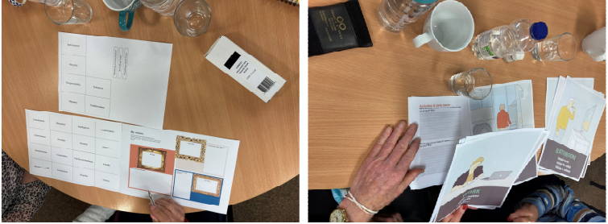
Figure 1: Co-design sessions using personas, scenarios and storyboards used to explain technology and design concepts in lay terms to participants

Acknowledgements
This material is based on works supported by the Science Foundation Ireland under Grant No. 19/FFP/6917 and is gratefully acknowledged.

References
Turner, J., Nugent, C., Berry, D., Wilson, M., Marron, A., Doyle, J., and O’Sullivan, D., 2022, A Goal-Driven Framework for Individualised Self-Care for Early-Stage Dementia. International Journal on Advances in Life Sciences, issn 1942-2660 vol. 14, no. 1 & 2, year 22:31.
Wilson, M., Doyle, J., Marron, A., Turner, J., Nugent C., and O’Sullivan, D., 2022 Co-design to support engagement in activities of daily living and meaningful activities for people living with dementia. Proceedings of ICCHP – AAATE 2022: 13th joint Conference on Digital Inclusion, Assistive Technology & Accessibility, Lecco, Italy, July 11-15.
Murphy, E., Gordon, D., Doyle, J., O’Sullivan, D., 2022, Towards an ethical framework for the design and development of inclusive home-based smart technology for smart spaces for older adults and people with disabilities. Proceedings of HealthInf 2022, 15th International Conference on Health Informatics. Online, February 9-11.

Paper ID: 5
Midwives’ Views of an Evidence-Based Intervention to Reduce Caesarean Section Rates in Ireland
Siobhan Corrigan¹ Vivienne Howard¹ Louise Gallagher² Valerie Smith² Kathleen Hannon² Margaret Carroll² & Cecily Begley²
¹School of Psychology, Trinity College Dublin, Dublin, Ireland
²School of Nursing & Midwifery, Trinity College Dublin, Dublin, Ireland

Abstract
Problem: A worldwide increase of caesarean section (CS) rates has been estimated at a rate of 4% per year and numerous interventions to reduce the rates have not been successful, perhaps because they are not acceptable to clinicians.
Background: A caesarean section (CS) can be a life-saving operation, but has been associated with short- and long-term risk factors and shown to affect subsequent pregnancies.
Aim: To explore midwives’ views on CS rates and evaluate the feasibility and acceptability of an evidence-based intervention programme (REDUCE) designed to decrease overall CS rates in Ireland by 7%.
Methods: Guided by an overall systems/Human Factors approach, a qualitative exploratory design was used to seek midwives’ views of the evidence-based intervention. A total of 28 midwives from one large tertiary maternity hospital took part in four focus group interviews. Data were analysed using thematic analysis.
Findings: Five themes emerged, illustrating the midwives’ views of what could be improved in the present system and how CS rates could be reduced in future. The themes included: (i) Induction of labour: (ii) Education; (iii) Auditing of practice; (iv) Clinical practice; (v) Midwife-obstetrician collaboration.
Discussion: This study noted a rising CS rate year on year, with a rate of 42% at the time of the study, and the midwives voiced their very real concerns over the increased high rates.
Conclusion: This study was critical in light of the worldwide increase of CSs. The evidence based ‘REDUCE’ intervention, was further modified and enhanced by the synthesised views of these midwives. The intervention should now be tested empirically in the Irish population, which may differ in its response, leading to different results and possible reductions in the rates of unnecessary CSs.
Key words: Caesarean section, Midwifery, Prenatal Care, Qualitative Methods, Systems Thinking, Human Factors, Intervention testing.

Paper ID: 6
Occupational Safety and Health Guidance for Remote Working
J. Cahill¹ & B. Molloy¹
¹ Health and Safety Authority, Metropolitan Building, James Joyce Street, Dublin 1.

Abstract
Introduction Remote working refers to work activities undertaken away from the employer’s normal work premises including in a domestic setting or a remote working hub.
Method
The ‘Occupational Safety & Health Guidance on Remote Working’ (Health and Safety Authority, 2023) was developed following a stakeholder evaluation process, involving the participation of both internal and external stakeholders.
Results
The responsibility for safety and health at work rests with the employer regardless of whether an employee works remotely or at the employer’s premises. Employers must provide a safe work environment and, in doing so, assess the risks and ensure appropriate controls are in place to safeguard employees at work. The assessment involves a three-step process. As indicated in Figure 1 below, the steps include (1) work activity, (2) assessment of hazards and (3) monitoring, reviewing, and communicating with employees.
The assessment of hazards includes both ergonomic and psychosocial hazards. Reporting of work-related accidents or incidents is also applicable to work undertaken remotely. It is the employer’s responsibility to proactively ensure that the assessment is completed for each employee by a suitably trained, competent person and account is taken of changing circumstances.
Discussion & Conclusions The Health and Safety authority have provided guidance on employer and employee roles and responsibilities in relation to remote working, and the remote working risk assessment process. It is important that employers and employees understand the risks and the management of work-related musculoskeletal health for employees who work at computer workstations in a domestic setting and/or remote working hub. Psychosocial hazards must also be considered.
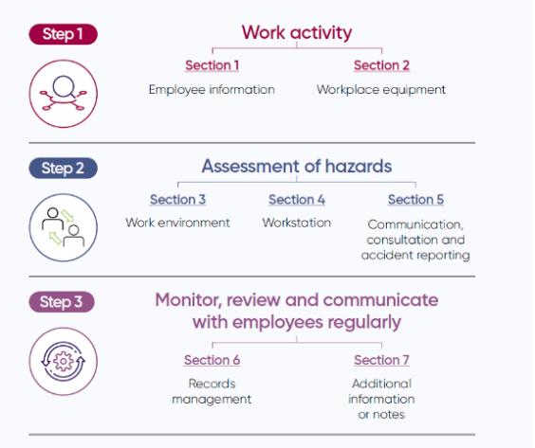
Figure 1: Assessment Process

References
Health and Safety Authority (2023). Occupational Safety & Health Guidance on Remote Working. Available at: https://www.hsa.ie/eng/topics/remote_working/remote_working_guidance.pdf

Acknowledgements
The Health and Safety Authority would like to thank all stakeholders involved in the production of this guidance.

Paper ID: 7
Analysis of Clinical Negligence Claims and Complaints Against GPS to The Irish Medical Council: Exploring Local Rationality and Performance Influencing Factors
S. Creed¹ and P. Bowie²
¹Edinburgh Medical School Clinical Sciences The University of Edinburgh, Edinburgh.
²NHS Education for Scotland, 3rd Floor, 2 Central Quay, 89 Hydepark Street, Glasgow. G3 8BW.

Abstract
Approximately 2-3% of General Practice (GP) consultations result in a Patient Safety Incident (PSI). Severe patient harm occurs in 4% of PSIs. (Panesar et al., 2016) Irish GP has 29 million consultations annually. (Collins and Homeniuk, 2021) It is likely that there is significant, potentially avoidable, patient harm occurring in Irish GP. Learning from PSIs is key to delivering high-quality safe patient care. Understanding local rationality (exploring the complex care system situation and focus of attention at that time) and applying a systems approach to analysing PSIs are promoted as a more meaningful way to understanding PSIs in complex systems. This may improve related learning and avoid unwarranted individual blame.

Method
A systems-based documentary analysis of randomly selected, 2019 clinical negligence claims and complaints in Irish GP was undertaken, informed by the Systems Engineering Initiative for Patient Safety (SEIPS) framework. (Carayon et al., 2006)

Aim
1. Explore the extent to which Local Rationality and Performance Influencing Factors (PIFs) are considered in clinical negligence claims and Irish Medical Council complaints against GPs. 2. Illustrate how the application of a ‘Systems Thinking’ approach to analysing clinical negligence claims and complaints could potentially enhance learning, improve patient safety and reduce clinician risk.

Results
Local rationality was not explicitly explored in claims or complaints. Patient factors were considered in all 19(100%) claims and 14(100%) complaints. The GP qualifications and training were considered in 3(16%) claims and 7(50%) complaints. Most other PIFs were not routinely captured. Figure 1

Conclusion
Local rationality is not routinely captured in claims or complaints. Embracing systems thinking is fundamental to provide meaningful insight into understanding PSIs in a complex system. This may enhance patient safety, improve clinician learning and reduce clinician risk.
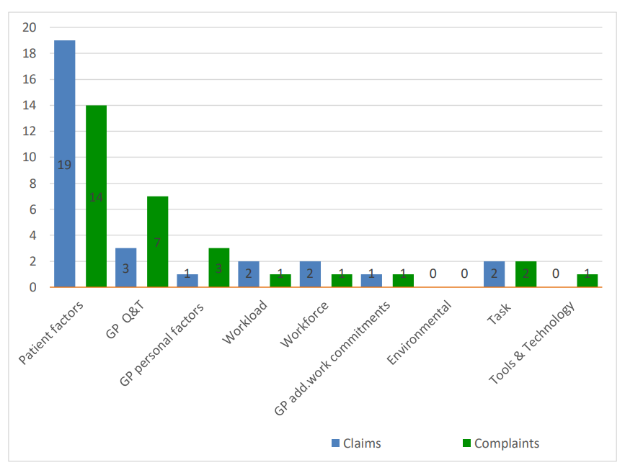
Figure 1: Comparative analysis of PIFs in claims and complaints
References
Carayon, P., Hundt, A.S., Karsh, B.-T., Gurses, A.P., Alvarado, C.J., Smith, M., Brennan, P.F., 2006. Work system design for patient safety: the SEIPS model. Quality & Safety in Health Care 15, i50. https://doi.org/10.1136/qshc.2005.015842
Collins, C., Homeniuk, R., 2021. How many general practice consultations occur in Ireland annually? Cross-sectional data from a survey of general practices. BMC Fam Pract 22, 1–9. https://doi.org/10.1186/s12875-021-01377-0
Panesar, S.S., deSilva, D., Carson-Stevens, A., Cresswell, K.M., Salvilla, S.A., Slight, S.P., Javad, S., Netuveli, G., Larizgoitia, I., Donaldson, L.J., Bates, D.W., Sheikh, A., 2016. How safe is primary care? A systematic review. BMJ Qual Saf 25, 544–553. https://doi.org/10.1136/bmjqs-2015-004178 A full list of references is available on request.
Acknowledgements
I would like to acknowledge the wonderful support from the CEO and colleagues at Medisec and from my research supervisor Professor Paul Bowie.

Paper ID: 8
Patient-Centred Human Factors: A Narrative Review in the ICU Context.
A.Keller & S. Dockrell
Discipline of Physiotherapy, School of Medicine, Trinity College Dublin.

Introduction
The environment in an Intensive Care Unit (ICU) should be one of healing. In this review, we consider a clinical case study within the ICU. We examine how the environment may be affecting patients' recovery and healthcare professionals (HCP) efficiency. We consider the effects of noise, light and physical environment on service users and HCPs within the ICU context.

The patient case
A 79-year-old lady 1-week post-operatively, mechanically ventilated, and heavily sedated. The patient was becoming extremely agitated when regaining consciousness and attempting to pull out the endotracheal tube. This scenario lends the question; how can we manipulate the environment to become more settling, sequentially decreasing the patient’s agitation, optimising recovery, and improving the efficiency of the HCPs involved?

Noise
Exceeding noise levels can negatively affect the patient's recovery through disturbed sleep and associated immune system dysfunction. It contributes to HCP fatigue and occupational burnout symptoms(Schmidt et al., 2020). Machine alarms should be silenced at the earliest opportunity. A ‘silent phone’ policy or noise-absorbing ceiling tiles could be introduced.
Light
There is evidence that exposure to natural light reduces agitation in patients in ICU(Smonig et al., 2019). This may be due to reduced circadian rhythm disruption, and preserved space and time orientation. It may also positively affect HCP as it has been shown to boost mood and productivity.

Physical Environment
There is conflicting evidence regarding centralized versus de-centralized nurses’ stations for the optimal ergonomics of ICU (Gurascio-Howard and Malloch, 2007). The space layout should be one that encourages collaboration between HCPs without decreasing nurses' time in patient rooms.

Conclusion
Noise, light and physical environment as ICU variables are not optimised in many ICU environments. Ultimately the environment must optimise 1;the patient and patient outcomes, 2;the clinician who delivers the care 3;population health and 4;systems that reduce cost. Improvements in this area could lead to shorter lengths of stay, improved quality of care, and a more cost-efficient healthcare system.

Reference
Gurascio-Howard, L. & Malloch, K. 2007. Centralized and decentralized nurse station design: an examination of caregiver communication, work activities, and technology. Herd, 1, 44-57.
Schmidt, N., Gerber, S. M., Zante, B., Gawliczek, T., Chesham, A., Gutbrod, K., Müri, R. M., Nef, T., Schefold, J. C. & Jeitziner, M. M. 2020. Effects of intensive care unit ambient sounds on healthcare professionals: results of an online survey and noise exposure in an experimental setting. Intensive Care Med Exp, 8, 34.
Smonig, R., Magalhaes, E., Bouadma, L., Andremont, O., De Montmollin, E., Essardy, F., Mourvillier, B., Lebut, J., Dupuis, C., Neuville, M., Lermuzeaux, M., Timsit, J. F. & Sonneville, R. 2019. Impact of natural light exposure on delirium burden in adult patients receiving invasive mechanical ventilation in the ICU: a prospective study. Ann Intensive Care, 9, 120.
Paper ID: 9
Evaluating Accessibility Issues in Healthcare Data Representation with Older Adults
Peterson Jean¹, Emma Murphy¹ and Enda Bates²
¹Technological University Dublin.
²Trinity College Dublin, Dublin.

Abstract
Consumer off-the-shelf wearable devices have become increasingly popular in patient-centred health care, allowing users to monitor and measure physiological parameters such as activity, sleep, heart rate, and blood pressure over time (Piwek et al., 2016). However, these devices often present data in graphs or text that may be difficult for older adults to understand without assistance, preventing them from fully benefiting from this data. Human factors research in healthcare has shown that ensuring proper representation of health information on medical devices reduces errors and improves safety considerations for medical experts. However, this task is more challenging when health information is presented directly to non-expert users through a wide range of devices. Thus, it is essential to address the accessibility of current data representation to older people and its impact on their engagement and overall safety of these apps. To address this issue, it is necessary to investigate the main problems with current data representation that influence older people's difficulty in correctly understanding the data being transmitted. A tailored protocol should be designed to conduct experiments with examples of actual data visual representation from these standard devices and their applications with a representative group of older people to gather human factor evidence. The protocol will focus on evaluating understanding based on the data representation rather than the competencies needed, as many existing user interface heuristics address a component of data representation. Qualitative analysis of the experiments will identify factors determining how critical parameters, such as blood pressure, should be presented and conveyed to older adults. The findings will inform a more safe and inclusive design prototype representing these physiological sensing parameters instead of traditional representations such as graphs.

Acknowledgements
This work was supported by Science Foundation Ireland Centre for Research Training in Digitally Enhanced Reality (d-real).

Reference
Lukasz Piwek, David A. Ellis, Sally Andrews, and Adam Joinson. 2016. The Rise of Consumer Health Wearables: Promises and Barriers. PLOS Medicine 13, 2 (February 2016), e1001953. DOI: https://doi.org/10.1371/journal.pmed.1001953
Paper ID: 10
Managing Mechanical Safety In Industrial Human-Robot Interaction
L. Gualtieri
Free University of Bozen-Bolzano, Faculty of Engineering, Piazza Domenicani 3, Bolzano, Italy.

Abstract
Collaborative robotics is one of the keys and enabling technology of Industry 4.0. Operators and robotic systems are supposed to share tasks and workspaces to achieve common production goals. This condition involves multiple advantages but also challenges. A major problem is related to mechanical safety: unwanted and unexpected contacts between the human and different parts of the robotic system may cause injuries and therefore limit the potential for collaboration. A mechanical hazard is a physical hazard, which can occur when workers directly or indirectly come into contact with process-related objects or machine elements. This can cause immediate and violent injuries to human beings. When designing a collaborative system, it is always necessary to consider that there is a conceptual and very important difference between a “collaborative robot” and a “collaborative application”. A collaborative robot arm presents different hardware and software inherent safety measures that allow the implementation of a safe human-robot interaction. Nevertheless, this will not directly guarantee the full safeguards of humans from the point of view of the mechanical hazards, especially considering the other parts of the robotic system (e.g. end-effectors), workcell elements (e.g. fixtures) and, process-related features (e.g. the workpiece). Thus, the fact that the robot is “collaborative” is not enough to consider the overall application as “safe”. This condition is even more exacerbated when the operator has to deal with advanced, i.e. increasingly autonomous and intelligent robotic systems. In this talk, after introducing the peculiarities of mechanical risks in industrial human-robot interaction, I will discuss the key concept of “collaborative application” and related modalities for the implementation of safe and efficient collaborative robotic systems.

Paper ID: 11
Foreign Object Management in Irish Hospitals
Prof. S. Corrigan, A. Kay, K. O’Byrne, Prof. S. Cromie.
Centre for Innovative Human Systems, School of Psychology, Trinity College Dublin, Dublin.

Abstract
This research introduces a socio-technical systems perspective on Foreign Object Management from the FOR-RaM Project (Foreign Object Retention - Reduction and Mitigation) which examined Foreign Object Management in Irish healthcare with specific reference to Surgery, Midwifery and Obstetrics. Retained foreign objects are rare because medical and nursing staff follow preventative procedures, but they still happen occasionally. There are approximately 200 cases in Ireland each year (Slattery, 2015, SCA, 2015). These cause significant physical and psychological impact on the patient, financial cost to the state and personal cost and reputational damage to the medical practitioners who are often considered to be the ‘second victim’ of foreign object retention. This research presents an understanding of how and why objects can be accidently retained and reports on proposed solutions and a toolkit of interventions implemented in two Irish hospitals to prevent foreign object retention.

Introduction
The FOR-RaM project was funded in 2016 by the Health Research Board (HRB) in Ireland due to a substantial portion the monies spent annually by the State Claims Agency (i.e., paid out following court cases and settlements) originating from one sole cause – that of foreign object retention (FOR). Approximately 200 incidents of FOR are reported each year in Ireland with more than 1000 cases being reported for the period from 2011-2015 (Slattery, 2015, SCA, 2015). While the rate and impact of FOR is recognised there is little understanding of the human and organisational factors leading to FOR or how to effectively address them. The core objectives of the project were: 1. Analyse the problem and current practice in the context of the Irish healthcare system. 2. Understand the problem and current practice in study hospitals. 3. Develop the hospital-specific foreign object management process and implementation roadmaps. 4. Consolidate the tools and methods. 5. Ensure impact in healthcare and academia. The project was lead by TCD, with the State Claims Agency lead knowledge user. An orthopaedic scrub nurse joined the research team for the duration of the project as a key researcher to advise the human factors experts (all with backgrounds in psychology) on the medical aspects of FOR, surgery, midwifery and obstetrics as well as taking part in the observations and validation exercises. Other partners in the project were:
- Irish Centre for Applied Patient Safety and Simulation, University Galway.
- Royal College of Surgeons, Ireland
- University Hospital Waterford
- Coombe Woman and Infants University Hospital
- University College Cork
- University College Dublin

Methods
The CUBE—A Socio-Technical Functional Model (McDonald et al 2021) was deployed as a key structure for both data gathering and analysis in the project. This model interrogated the socio-technical system from the current state of FOR in Irish Healthcare – the “As is” picture and how it could be in the future – the “To-be” picture. A variety of research activities took place in order to gather and analyse data on how FOR was prevented now and how it could be managed in the future. These were:
- Semi-structured Interviews
- Observations in Theatre (Surgery, Midwifery & Obstetrics)
- Observations in Delivery Suite (Midwifery & Obstetrics)
- Focus Groups
- Document Analysis
- Action Learning Sets
- Implementation Workshops (clinical sites)
- Validation Workshops (clinical sites & Scientific Advisory Board)

Research tools
Operational Process Mapping and Bow Ties were produced for both the “As is” and “To-be” perspectives. The authors also deployed Co-ordination Demand Analysis and an analysis of the Performance Shaping Factors observed on-site for both “As-is” and “To-be” rounds of observations. Comparison was also made between the level of co-ordination between teams across the different phases of research.
Results
Table 1 highlights the interventions implemented during the FOR-RaM project.
Intervention | Speciality
Protecting the integrity of the Count | Surgery
Quiet for the Count | Both Surgery & Midwifery/ Obstetrics
Verbal Acknowledgement of the Count | Surgery
Champions | Surgery (informal)
Standardisation of Whiteboards | Surgery
2-person sign off for the Count | Both Surgery & Midwifery/ Obstetrics
Formalise Count for Transfer of Patients | Midwifery & Obstetrics
“Sign in” and “Sign out” | Midwifery & Obstetrics
Table 1: Interventions to prevent FOR implemented during FOR-RaM project
As can be seen in Table 1, eight interventions were implemented during the FOR-RaM project. All research activities employed co-design throughout all phases of research. The authors worked with each hospital site to produce their own roadmap with bespoke interventions. Some interventions such as Champions were not fully implemented due to the COVID-19 pandemic as all on-stie research activities in the FOR-RaM project (understandably) ceased. However, it is of interest to note that the above interventions were carried out throughout the pandemic. This is testament to the level of commitment from hospital staff at both sites and indeed the importance they placed on preventing FOR despite the challenges faced during COVID-19.

Recommendations
The following represents some of the recommendations from the FOR-RaM project. These are categorised according to McDonald’s CUBE framework (McDonald et al, 2021).
Goals
- Raising the profile of count should be a priority goal for all members of the surgical team and supporting roles.
- Protecting the integrity of the count should be adhered to and maintained in Irish healthcare settings.
- Preventing the occurrence of foreign objects should be a shared goal and seen as a team responsibility amongst all stakeholders in Surgery, Midwifery and Obstetrics
Processes
- Procedures for the safe transfer process and handover of patients from one location to another should be introduced, especially after objects have intentionally been retained.
- “Quiet” for the Count, Time Out and Surgical Safety Checklist should be called for and instilled in training from undergraduate level upwards. This should form a key part of any specific training on FOR at all levels (undergraduate, post-graduate, Continuing Professional Development [CPD]).
- The formal sign-out of the count outcome should be completed by two persons in all cases. This should be trained for and surgical documentation updated to include a specific area for the two-person sign-out.
Information and Knowledge
- The count outcome should be verbalised and acknowledged to ensure that both parties have acknowledged the communication of the count as a matter of both procedure and respect.
- Advocates for patient liaison with hospital, community healthcare representatives, legal representatives, patient representative bodies should be considered. Patients reported this to be of great importance.
- Reporting of instances of count inconsistencies should be encouraged as a routine practice. This is to ensure that valuable information on near-misses is not lost.
- Lessons learned from near-misses in healthcare and other safety critical industries should be part of specific training on FOR at all levels.
Technology
- Further research is recommended on how technologies such as bar-coding, RFID and AI may support the prevention of FOR and its earlier detection in Irish Healthcare settings.
- Databases within the HSE and State Claims agencies should be designed to facilitate reporting such that fully anonymised patient records are available for research under EU GDPR guidelines.
Teamwork
- Multi-disciplinary team training on FOR prevention and management should be given from post-graduate level onwards as part of ongoing CPD.
Culture
- It is recommended that staff be treated with respect following an incidence of FOR, the importance of which has been recognised with never-events in healthcare settings
- An open culture where people feel able to speak up should be fostered and maintained at all levels in surgery, midwifery and obstetrics.
- Support for hospital staff is recommended to enable them to speak up when they feel that they are unable to perform their duties safely or without introducing risk to the patient care and further risk to themselves.
- Support for staff after FOR is recommended as essential in the immediate aftermath, throughout any investigation and in the long-term to ensure that the event does not impact their wellbeing and performance at work in the future.
- It is recommended that all staff in the team (where FOR occurred) are supported and that the team is made aware of what went wrong and what could be done differently in the future from a just-culture perspective.
- It is recommended that the culture of the “near miss” be reviewed in Irish healthcare settings as this appears to be different to that in other safety critical industries.
Acknowledgements
The authors gratefully acknowledge the Health Research Board of Ireland who provided a Grant for this research under the Research Collaborative in Quality and Patient Safety. The authors also gratefully acknowledge all stakeholders who gave of their time for this research and in particular the staff and management across the two hospital sites.

Reference
McDonald, N., McKenna, L., Vining, R., Doyle, B., Liang, J., Ward, M.E., Ulfvengren, P., Geary, U., Guilfoyle, J., Shuhaiber, A., Hernandez, J., Fogarty, M., Healy, U., Tallon, C. and Brennan, R (2021).; Evaluation of an Access-Risk Knowledge (ARK) Platform for Governance of Risk and Change in Complex Socio-Technical Systems. Int. J. Environ. Res. Public Health 2021, 18, 12572.
Slattery, D. (2015), Clinical Incidents and Claims Report in Maternity and Gynaecology Services: A five Year Review: 2010-2014. Published by the State Claims Agency in Ireland.
State Claims Agency (2015), National Clinical Incidents, Claims and Costs Report: Lessons Learned, A five Year Review: 2010-2014.Published by the State Claims Agency in Ireland.

Paper ID: 12
Neuroergononomics and Physiological Computing: New Methods To Enhance Human-System Interaction
Raphaëlle N. Roy
ISAE-SUPAERO, Université de Toulouse, France

Abstract
Within the context of human-system interaction research, the usual metrics to characterize operators’ mental state are comprised of subjective metrics obtained through the use of questionnaires or interviews, and behavioural metrics such as performance ones (e.g. accuracy and response times). In recent decades, a complementary approach has been proposed, based on the use of physiological measurements (e.g. cardiac, electrodermal and cerebral measurements). The advantages of the metrics that can be extracted from these measurements include their objective nature and the fact that they allow to perform online measurements without interrupting the task at hand. The use of neuroscience tools to study humans at work, or Neuroergonomics, is a field of research that has grown at a fast pace these recent years. Going a step further, thanks to signal processing and machine learning tools we can now process physiological measures automatically, and even adapt the interaction according to the detected state in order to improve safety and performance, and in a general manner to enhance the interaction. Known as physiological computing, this approach can be found in several research areas under various terms. When concerned only about cerebral activity, the usual term is passive brain-computer interfaces (Roy et al., 2020). Neuroergonomic and physiological computing studies have for instance allowed to characterize and detect cognitive phenomena such as inattentional deafness and cognitive states such as variations in mental workload in the aeronautical context (e.g. Dehais et al., 2019; Singh et al., 2022). These new methods can efficiently complement existing ones to provide additional information about operators’ mental states, and improve their assessment, but also provide a new means to modulate human-system interaction hence paving the way to physiology-based enhanced interaction techniques.

References
Dehais, F., Roy, R. N., & Scannella, S., 2019, Inattentional deafness to auditory alarms: Interindividual differences, electrophysiological signature and single trial classification, Behavioural brain research, 360, 51-59.
Roy, R. N., Drougard, N., Gateau, T., Dehais, F., & Chanel, C. P., 2020, How can physiological computing benefit human-robot interaction?, Robotics, 9(4), 100.
Singh, G., Roy, R. N., & Ponzoni Carvalho Chanel, C., 2022, POMDP-based adaptive interaction through physiological computing, HHAI Conf., June 2022, Amsterdam, NL

